Lab 02 — Cross-Site Scripting (XSS) Lab
Ikemuefuna Uzoh: xeo102
IS 4463-CY1 – Summer 2019
July 12, 2026

Introduction
This lab explores Cross-Site Scripting (XSS), a common web vulnerability that allows attackers to inject malicious JavaScript into a victim's browser and bypass same-origin policy protections to steal sensitive data such as session cookies. Using a deliberately vulnerable installation of the Elgg social networking platform, this lab investigates how such vulnerabilities can be exploited to compromise user profiles and propagate malicious code across a network of users.

Procedure
The lab began by confirming that the target application, the deliberately vulnerable Elgg installation "One Bad Place" hosted at xsslabelgg.com, was reachable in the browser. Alice's profile page was loaded to verify the environment was functional before any payload was introduced.
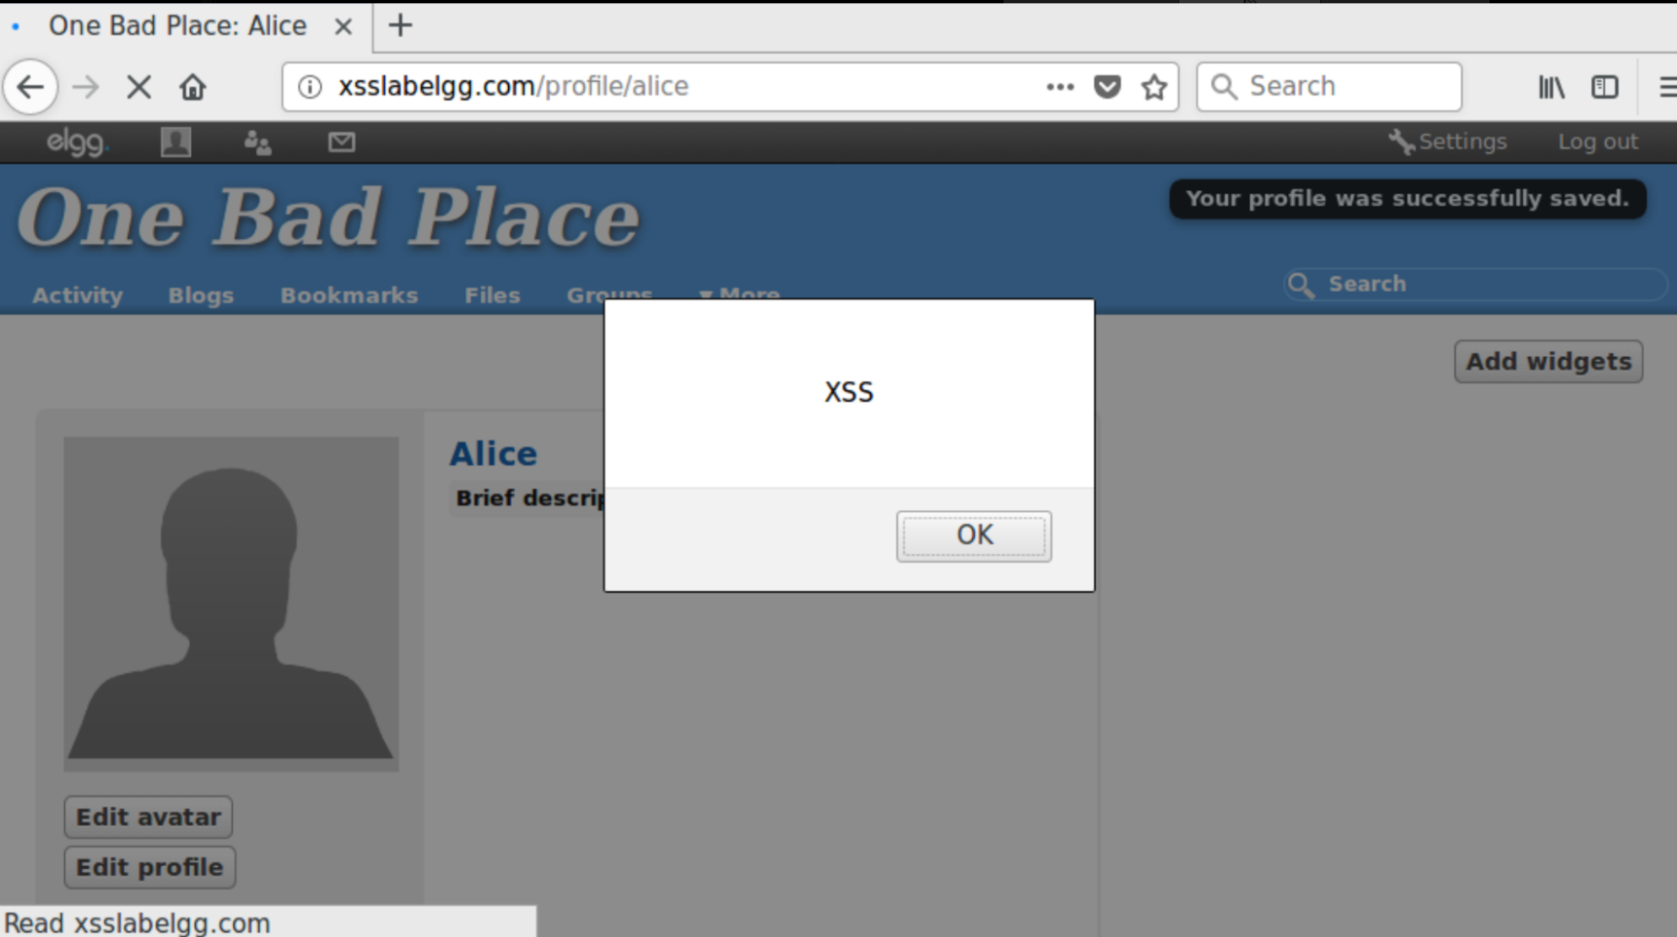
Figure 1. The vulnerable Elgg web application ("One Bad Place") loaded in the browser at xsslabelgg.com/profile/alice, confirming the target environment is up and reachable prior to injecting any payload.
Next, a JavaScript payload was crafted and entered into a user-editable field on Alice's profile (the "Brief description" field). Because Elgg stored this field's contents without properly sanitizing or encoding them, the payload was persisted directly to the database — this is what makes the vulnerability a stored (persistent) XSS rather than a reflected one. The alert box in the screenshot below fired immediately upon saving the profile, which confirmed the payload executed at save time and that the field was not filtering script content.
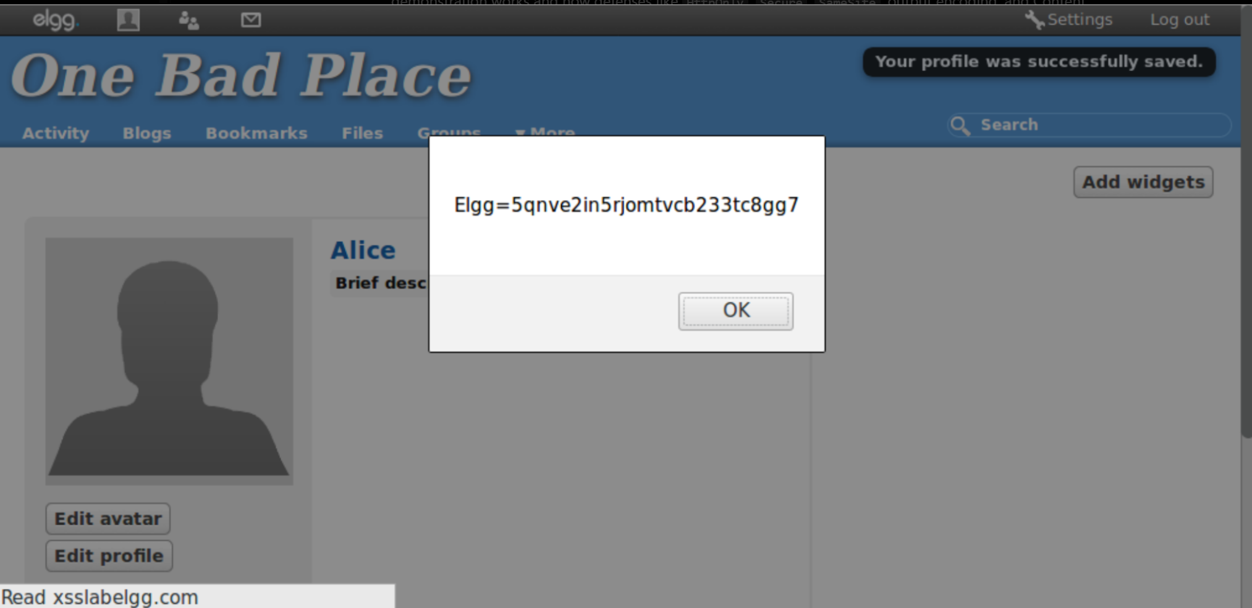
Figure 2. The malicious payload entered into Alice's profile "Brief description" field. The alert box firing on save ("Elgg=5qnve2in5rjomtvcb233tc8gg7", Elgg's session/CSRF token) demonstrates the injected script executed in-browser and was able to access session-related data as part of the page context — not just a static string being reflected back.
To demonstrate real-world impact beyond a simple alert() pop-up, the payload was extended to exfiltrate data to an attacker-controlled listener. A simple TCP echo server was started on the attacker machine (172.25.0.3) using the echoserv utility on port 5555. When a victim later browsed to Alice's now-compromised profile page, the stored script executed in the victim's browser session and made an outbound HTTP GET request back to the attacker's listener, carrying the stolen session token as a URL parameter. The terminal capture below shows this callback arriving twice, once for the initial page load and once for the browser's automatic favicon.ico request, confirming the exfiltration channel worked end-to-end without any action from the victim beyond viewing the page.
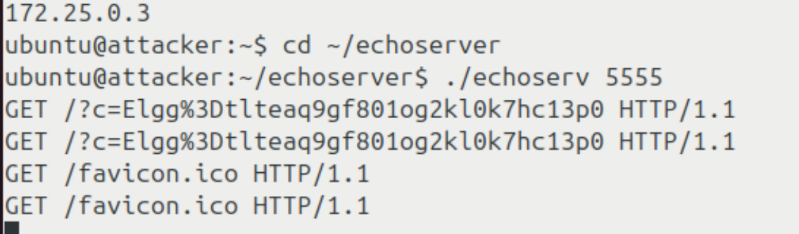
Figure 3. Attacker-side terminal running an echo server (echoserv) on port 5555. The incoming GET requests ("GET /?c=Elgg%3Dtlteaq9gf8o1og2kl0k7hc13p0") show the victim's browser automatically executing the stored payload and sending the session identifier to the attacker's listener — proof that the stored XSS payload propagates to any user who simply views the compromised profile.
After demonstrating the exploit, the lab moved to countermeasures. The Elgg administration panel was used to enable the HTMLawed 1.8 plugin under Administration → Plugins → Security and Spam. HTMLawed is an input-sanitization filter designed to strip or neutralize dangerous HTML/JavaScript tags before they are stored. To confirm the raw server response and page structure before re-testing the payload, the HTTP response for the profile page was also inspected directly, showing the underlying Elgg 1.8.19 page structure, stylesheet links, and metadata that the browser renders.
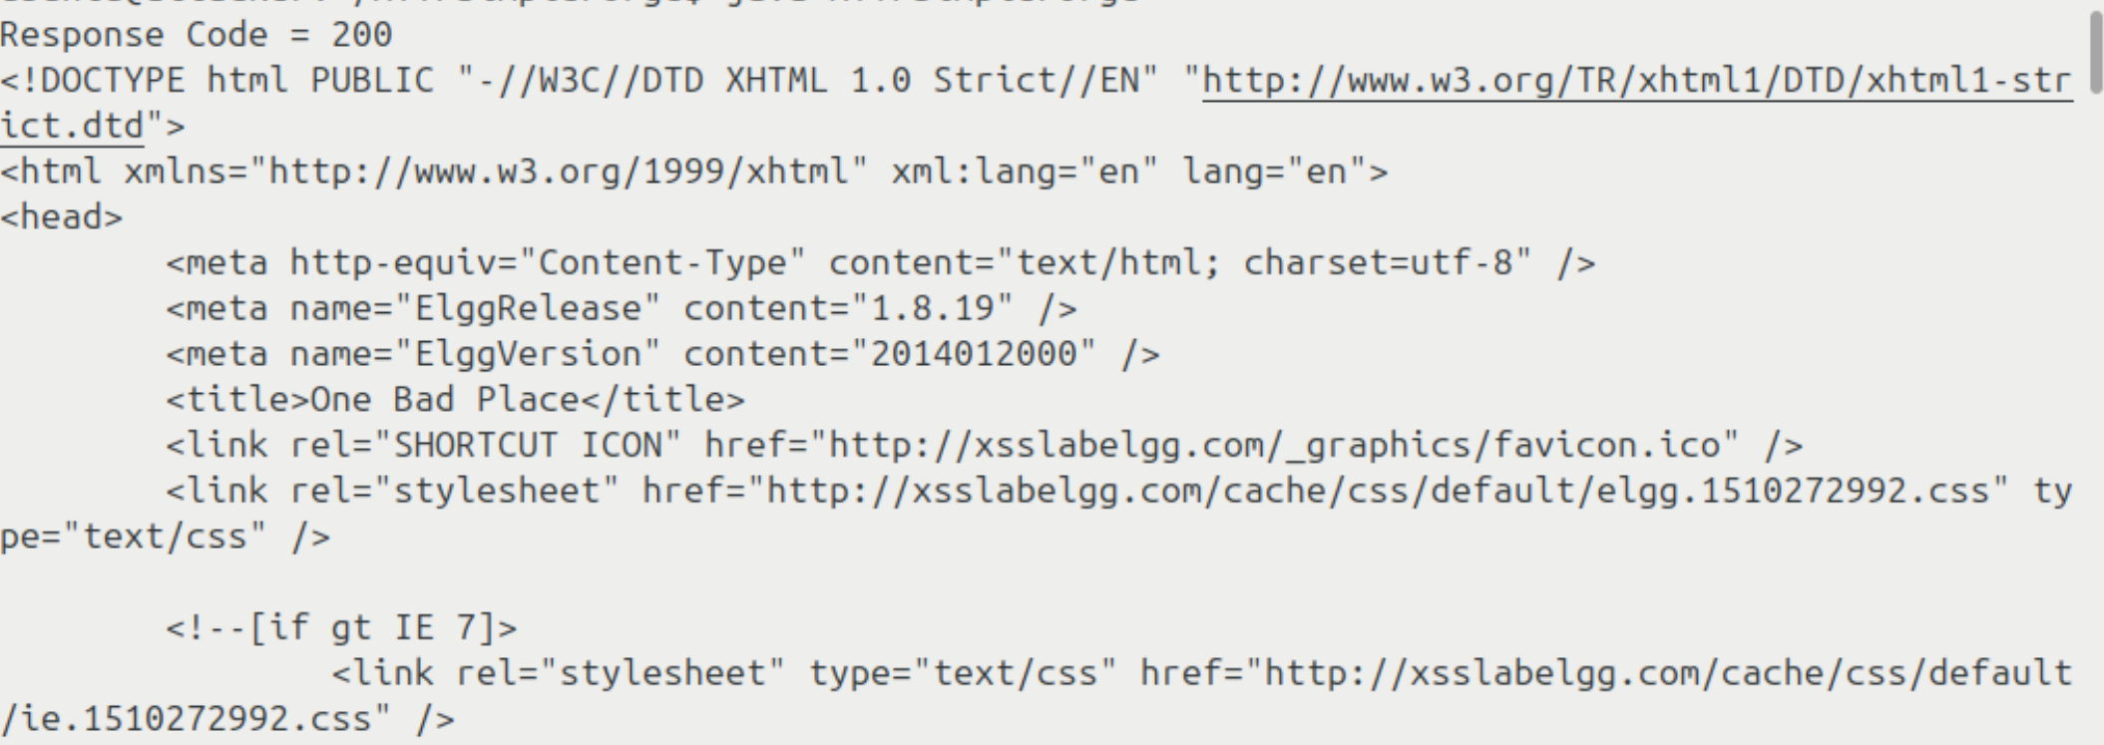
Figure 4. Raw HTTP response (Response Code = 200) for the Elgg profile page, showing the page's DOCTYPE, ElggRelease/ElggVersion metadata (1.8.19 / 2014012000), and linked stylesheets. Inspecting the response directly, rather than only the rendered page, was used to confirm exactly what markup the server was sending before and after the HTMLawed countermeasure was activated.
With HTMLawed active, the same stored payload was reloaded on Alice's profile to test whether the countermeasure blocked execution. Instead of triggering an alert box as it had in Figure 2, the payload now appeared as inert plain text directly on the page — the literal characters alert('XSS'); were displayed to the viewer rather than being interpreted as executable JavaScript. This confirmed that HTMLawed's input sanitization, combined with Elgg's output-encoding via htmlspecialchars(), successfully neutralized the attack by ensuring the browser treated the payload as data to display, not code to run.
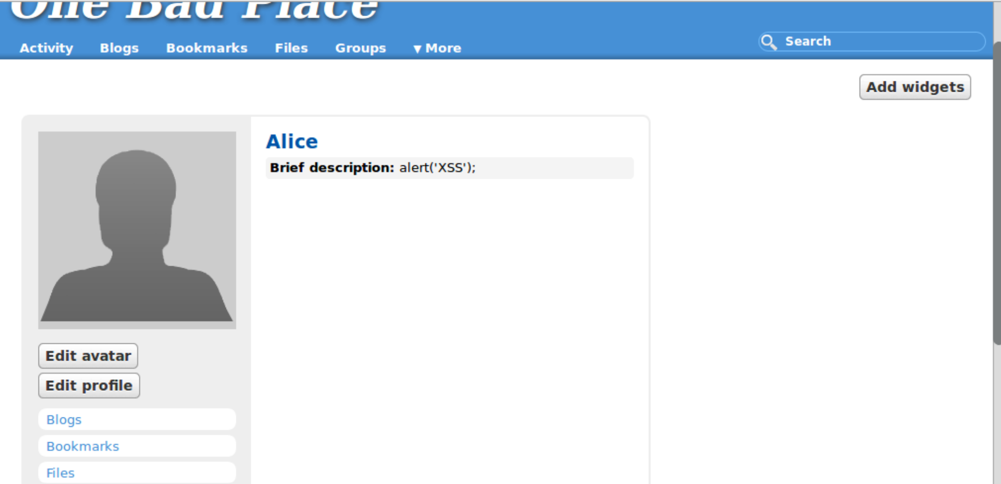
Figure 5. Alice's profile page after the HTMLawed 1.8 countermeasure was activated. The "Brief description" field now displays the literal text alert('XSS'); as plain, inert content instead of executing it — direct visual confirmation that the sanitization and output-encoding countermeasures successfully blocked the stored XSS attack demonstrated in Figures 1–3.

Conclusion
In this lab we learned how a web application can fail to validate or sanitize user supplied input and reflect it back to other users, leading to Cross-Site Scripting (XSS) vulnerabilities. The techniques used in this lab were mainly to show what an attacker can do with arbitrary JavaScript in the browser of a victim. In this case the victim would be browsing to a compromised page (i.e. a user profile) and would be susceptible to a stored attack. The attacker would inject a malicious <script> payload into a stored field in a vulnerable Elgg installation. Such an attack is directly applicable to real world security, as stored XSS is still one of the most common and dangerous web application vulnerabilities in practice. The same mechanism can be used in production environments to hijack session cookies, impersonate users, deface content, redirect victims to phishing sites, or silently propagate malware across a platform's user-base, without any obviously risky action by the victim other than viewing a page they trust.
The attack was thwarted by the output-encoding function htmlspecialchars() and the input-sanitization plug-in HTMLawed, in a way not achieved by any of the countermeasures studied in this lab. HTMLawed was supposed to strip dangerous tags from user input before storing, and htmlspecialchars() converted special characters so any payloads would be displayed as text, not as executable code. Seeing both countermeasures in action drove home one of the best practices of defense-in-depth in the real world: relying on a single layer of protection, like input sanitization alone, leaves an application vulnerable if that layer is ever misconfigured or bypassed. Input validation + output encoding = much stronger, much more resilient defense.
This lab was not too hard but did take some understanding of how Elgg accepts and displays user input through various PHP files. Also a close look at file permissions and plugin configuration. And the hands-on aspect of the lab, actually building a working payload and watching it perform, was so much more concrete and memorable an experience than just reading about it alone. I want to go a little deeper and talk about some of the more advanced types of XSS such as DOM based XSS and also some of the modern browser level protections such as Content Security Policy (CSP) headers that can prevent inline script execution even if sanitization fails.

References
[1] Essential Javascript – A Javascript Tutorial. http://www.hunlock.com/blogs/Essential_Javascript_--_A_Javascript_Tutorial
[2] The Complete Javascript Strings Reference. http://www.hunlock.com/blogs/The_Complete_Javascript_Strings_Reference
[3] Technical explanation of the MySpace Worm. http://namb.la/popular/tech.html
[4] Elgg Documentation. http://docs.elgg.org/wiki/Main_Page

